**Sign up for a Twilio Account**

Browse to twilio.com

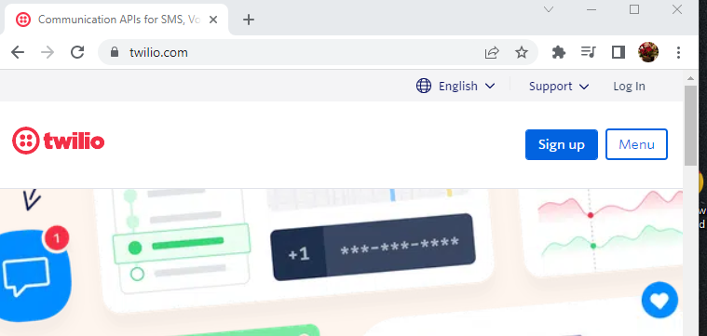

Click Sign up

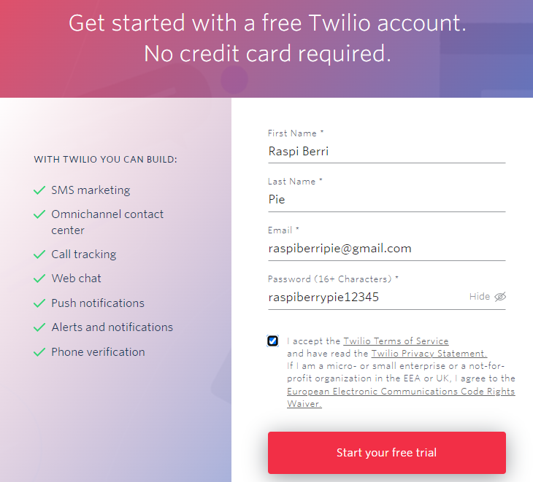

Fill up the form and click Start your free trial

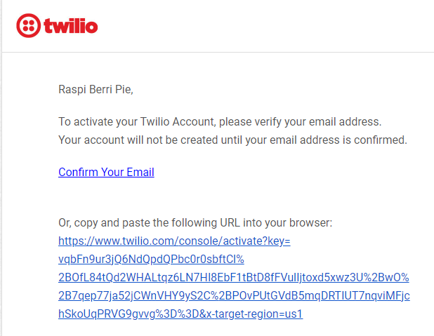

Open Gmail Account look for this email from Twilio

Click Confirm Your Email

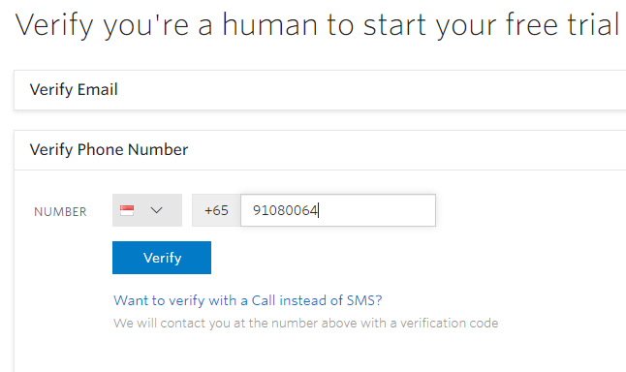

Enter the Phone Number you use for this Account

Click Verify. Twilio will send you a verification code by SMS.

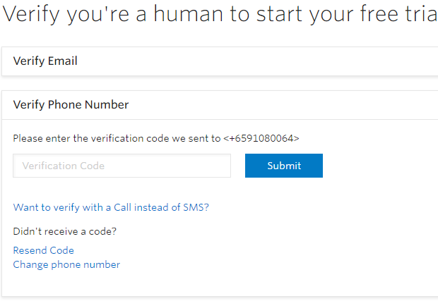

Enter the Verification Code and click Submit

You will see this on the screen. Fill up the form as shown here.

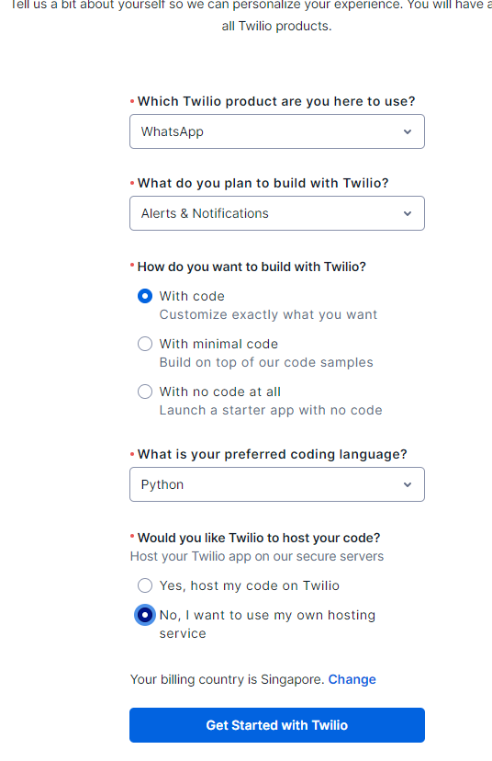

Then Click Get Started with Twilio

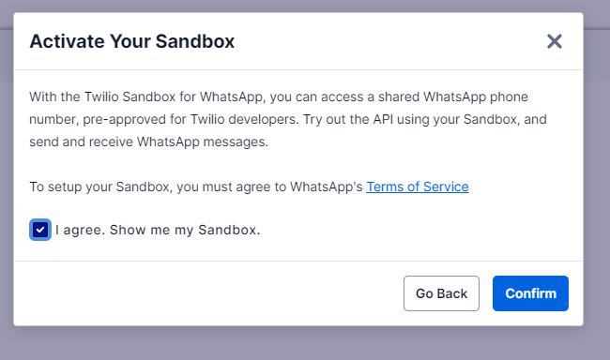

Check I agree. Show me my Sandbox and click Confirm

You will be asked to send a Whatsapp Message using your Handphone to Twilio:

Send this message : **join burn-busy**

To this number : **+14155238886** (you may need to create this as a new contact)

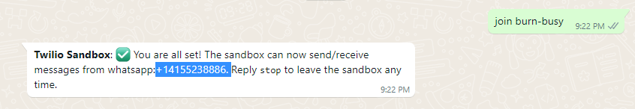

Twilio will send you a reply once you send the msg to them. You will see this on your screen as well

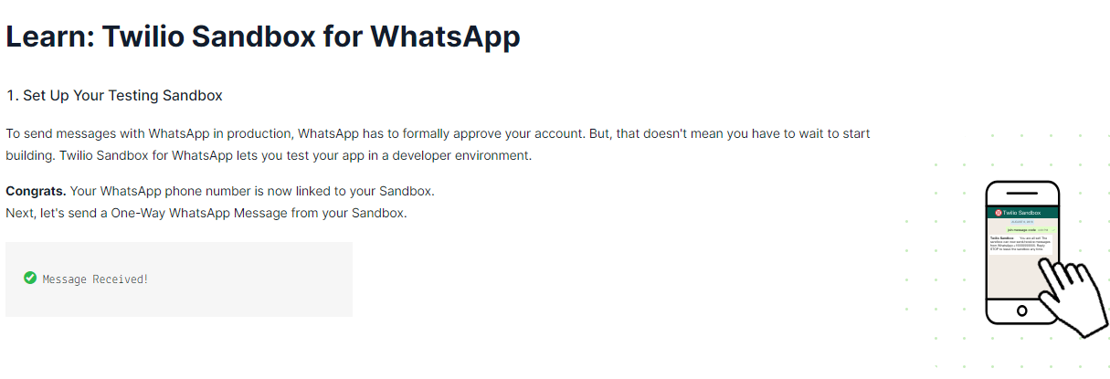

Your Twilio Sandbox is now successfully created.